1.
a) 3
b) Error since x is still unbound in the first 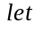 expression.

